## 

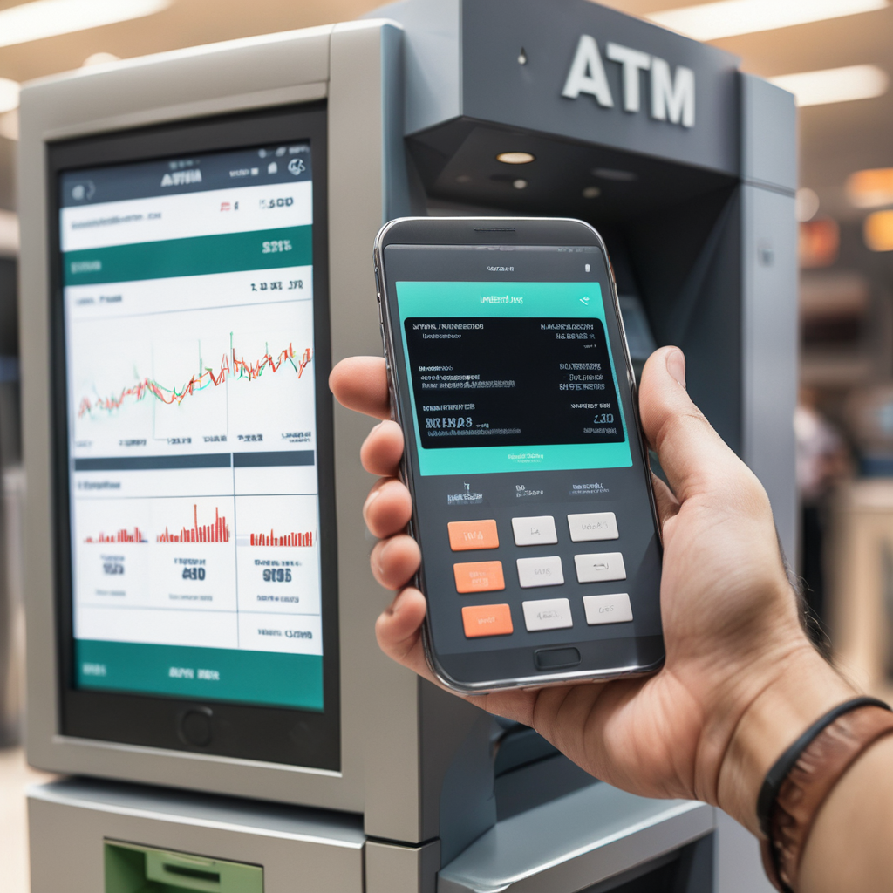

Mobile Manufacturer Data Analysis_ATM

**─**

Your Name

Daksh Sinha

# Overview

Business Scenario: The database “Cellphones Information” contains details on cell phone sales or transactions.

# DATA ANALYSIS

1 . List all the states in which we have customers who have bought cellphones from 2005 till today.

→SELECT State FROM DIM_LOCATION AS DL

JOIN FACT_TRANSACTIONS AS FT ON FT.IDLocation = DL.IDLocation

JOIN DIM_CUSTOMER AS DC ON DC.IDCustomer = FT.IDCustomer

WHERE DATE >= '2005-01-01'

GROUP BY State

2 . What state in the US is buying the most 'Samsung' cell phones?

→SELECT TOP 1 State FROM DIM_LOCATION AS DL

JOIN FACT_TRANSACTIONS AS FT ON FT.IDLocation = DL.IDLocation

JOIN DIM_MODEL AS DMO ON DMO.IDModel = FT.IDModel

JOIN DIM_MANUFACTURER AS DM ON DM.IDManufacturer = DMO.IDManufacturer

WHERE Country = 'US' AND Manufacturer_Name LIKE 'S%'

GROUP BY State

3 . Show the number of transactions for each model per zip code per state.

→SELECT ZipCode, State, FT.IDModel, Model_Name, COUNT(FT.IDModel) AS CNT FROM DIM_LOCATION AS DL

JOIN FACT_TRANSACTIONS AS FT ON FT.IDLocation = DL.IDLocation

JOIN DIM_MODEL AS DMO ON DMO.IDModel = FT.IDModel

GROUP BY ZipCode, State, FT.IDModel, Model_Name

4 . Show the cheapest cellphone (Output should contain the price also)

→SELECT TOP 1 DM.IDManufacturer, Manufacturer_Name, IDModel, Model_Name, Unit_price FROM DIM_MODEL AS DMO

JOIN DIM_MANUFACTURER AS DM ON DM.IDManufacturer = DMO.IDManufacturer

ORDER BY Unit_price

5 . Find out the average price for each model in the top5 manufacturers in terms of sales quantity and order by average price.

→CREATE FUNCTION MULTIPLY(@TOTALPRICE FLOAT, @UNITPRICE FLOAT)

RETURNS FLOAT

BEGIN

RETURN (@TOTALPRICE*@UNITPRICE)

END

WITH TEMP (Manufacturer_Name)

AS (

SELECT TOP 5 DM.Manufacturer_Name FROM DIM_MANUFACTURER AS DM

JOIN DIM_MODEL AS DMO ON DMO.IDManufacturer = DM.IDManufacturer

JOIN FACT_TRANSACTIONS AS FT ON FT.IDModel = DMO.IDModel

GROUP BY DM.Manufacturer_Name

ORDER BY SUM([dbo].[MULTIPLY](TotalPrice,Unit_price)) DESC

)

SELECT FT.IDModel, AVG(TotalPrice) AS AVG_

FROM FACT_TRANSACTIONS AS FT

JOIN DIM_MODEL AS DMO ON DMO.IDModel = FT.IDModel

JOIN DIM_MANUFACTURER AS DM ON DMO.IDManufacturer = DM.IDManufacturer

WHERE DM.Manufacturer_Name IN (

SELECT Manufacturer_Name FROM TEMP

)

GROUP BY FT.IDModel

ORDER BY AVG_

6 . List the names of the customers and the average amount spent in 2009, where the average is higher than 500

→SELECT DIM_CUSTOMER.*

FROM DIM_CUSTOMER

JOIN

(

SELECT IDCustomer, AVG(TotalPrice) AS AVG_ FROM FACT_TRANSACTIONS

WHERE YEAR(DATE) = 2009

GROUP BY IDCustomer

HAVING AVG(TotalPrice) > 500

) AS T

ON T.IDCustomer = DIM_CUSTOMER.IDCustomer

7 . List if there is any model that was in the top 5 in terms of quantity, simultaneously in 2008, 2009 and 2010

→WITH TEMP AS

(

SELECT IDModel, YEAR(DATE) AS YEAR_, SUM(Quantity) AS OVERALL_QTY, DENSE_RANK() OVER (PARTITION BY YEAR(DATE)

ORDER BY SUM(Quantity) DESC) AS RANK_

FROM FACT_TRANSACTIONS

WHERE YEAR(DATE) IN (2008, 2009, 2010)

GROUP BY IDModel, YEAR(DATE)

)

SELECT IDModel FROM TEMP

WHERE

(YEAR_ = 2008 AND RANK_ <= 5)

OR (YEAR_ = 2009 AND RANK_ <= 5)

OR (YEAR_ = 2010 AND RANK_ <= 5)

GROUP BY IDModel

HAVING COUNT(*) =3

8 . Show the manufacturer with the 2nd top sales in the year of 2009 and the manufacturer with the 2nd top sales in the year of 2010.

→WITH TEMP AS

(

SELECT Manufacturer_Name, YEAR(DATE) AS YEAR_, SUM(TotalPrice) AS TOTAL_SALES, DENSE_RANK() OVER (PARTITION BY YEAR(DATE)

ORDER BY SUM(TotalPrice) DESC) AS SALES

FROM DIM_MANUFACTURER AS DM

JOIN DIM_MODEL AS DMO ON DMO.IDManufacturer = DM.IDManufacturer

JOIN FACT_TRANSACTIONS AS FT ON FT.IDModel = DMO.IDModel

WHERE YEAR(DATE) IN (2009, 2010)

GROUP BY Manufacturer_Name, YEAR(DATE)

)

SELECT Manufacturer_Name, YEAR_, TOTAL_SALES FROM TEMP

WHERE SALES = 2

9 . Show the manufacturers that sold cellphones in 2010 but did not in 2009.

→SELECT TOP 1 Manufacturer_Name

FROM DIM_MANUFACTURER AS DM

JOIN DIM_MODEL AS DMO ON DMO.IDManufacturer = DM.IDManufacturer

JOIN FACT_TRANSACTIONS AS FT ON FT.IDModel = DMO.IDModel

WHERE YEAR(DATE) IN (2009, 2010)

GROUP BY Manufacturer_Name

ORDER BY COUNT(Manufacturer_Name) OVER (PARTITION BY Manufacturer_Name)

10 . Find top 10 customers and their average spend, average quantity by each year. Also find the percentage of change in their spend.

→SELECT * , ((AVG_SPEND - LAG_PRICE)/LAG_PRICE) AS CHANGE_PERCENTAGE FROM (

SELECT *, LAG(AVG_SPEND,1) OVER (PARTITION BY IDCUSTOMER ORDER BY YEAR_) AS LAG_PRICE FROM

(

SELECT IDCustomer, YEAR(DATE) AS YEAR_, AVG(TotalPrice) AS AVG_SPEND, AVG(Quantity) AS QTY

FROM FACT_TRANSACTIONS

WHERE IDCustomer IN (

SELECT TOP 10 IDCustomer FROM FACT_TRANSACTIONS

GROUP BY IDCustomer

ORDER BY AVG(TotalPrice) DESC

)

GROUP BY IDCustomer, YEAR(DATE)

) AS A

) AS B